SUMMERVILLE CREDIT UNION · CONSOLIDATED MEMBER GUIDE
Manage Cards

Module: nFinia Digital Banking > Cards
01 PRODUCT SUMMARY

The Cards section is the central hub for all card management activities within Summerville Credit Union online banking. From here you can view all debit and credit cards linked to your membership, check balances and credit limits, toggle card status on or off, and access card-specific actions including Card Controls, Set PIN, Deactivate / Replace Card, and View Account.
Cards are listed by account and can be filtered using the Select Account dropdown. Each card tile shows the card image, masked card number, expiry, membership number, Card Status toggle, available credit or balance, and quick action links. Both debit and credit cards are shown together on the same screen.

At a Glance
Attribute | Detail
Module | nFinia Digital Banking > Cards
Access | Top navigation bar > Cards
Cards Shown | All debit and credit cards linked to the membership
Filter Option | Filter by account using the Select Account dropdown
Quick Actions | Card Controls, Set PIN, Deactivate / Replace Card, View account
Card Status | Toggle On/Off directly from the card tile

02 KEY USE CASES

Use Case | Who Uses It | What They Do | Business Value
View all cards | Member wanting an overview of all their cards | Navigates to Cards from the top navigation bar | Single view of all debit and credit cards with balances and status
Check available credit | Member wanting to know remaining credit | Opens Cards section and reads Available credit on the card tile | Instant balance and credit limit visibility without calling the CU
Toggle card status | Member who wants to temporarily disable a card | Clicks the Card Status toggle on the relevant card tile | Card is frozen or unfrozen immediately from the cards list
Access card actions | Member who needs to update PIN or manage controls | Clicks Card Controls, Set PIN, or Deactivate / Replace Card links on a card tile | One-click access to all card management functions

03 STEP-BY-STEP GUIDE

Navigation: Log in to Summerville Credit Union online banking. Click Cards in the top navigation bar.
Step 1 — Arrive at the Dashboard
After logging in, you land on the Dashboard showing your account balances, recent payments, and quick-action shortcuts. The Cards section is accessible directly from the top navigation bar.
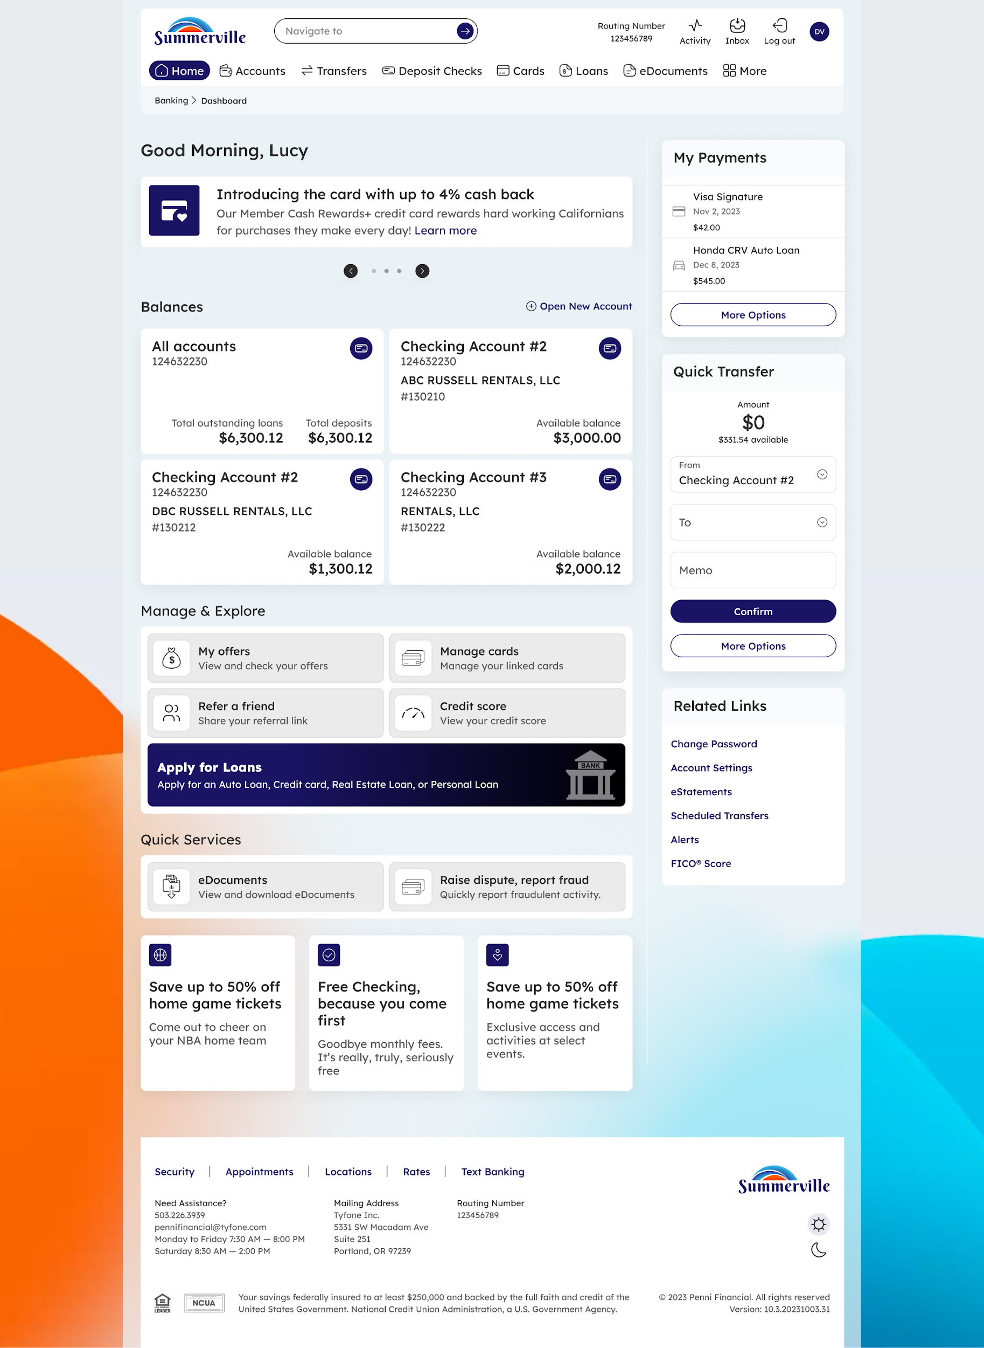
Step 1: Dashboard — starting point for navigation
Step 2 — View Your Cards List
The Cards page displays all cards associated with your membership. Each card tile shows the card image and design, masked card number, expiry date, membership number, and a Card Status toggle. Below the card details you will see Available credit, Current balance, and quick action links: Card Controls | Set PIN | Deactivate / Replace Card | View account. Use the Select Account filter to show cards for a specific account only.
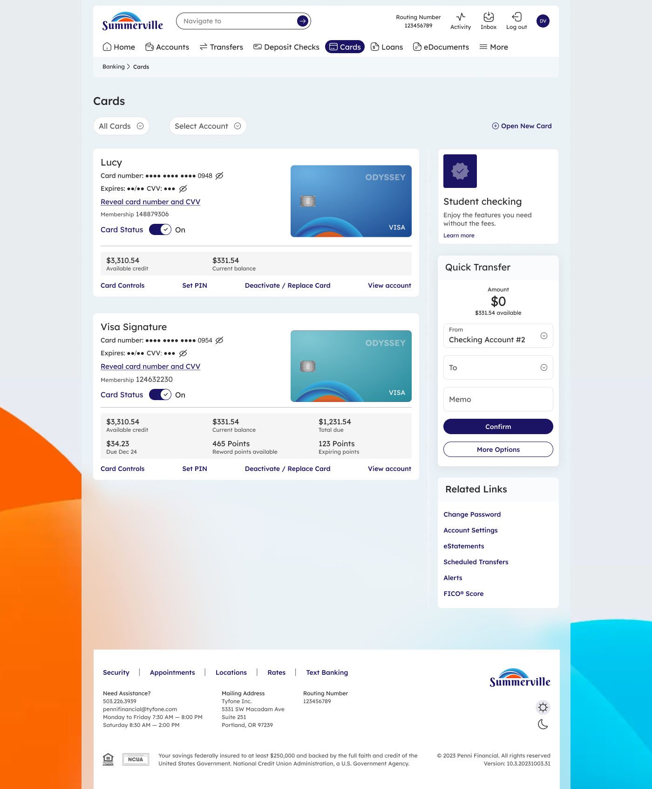
Step 2: Cards list — all your debit and credit cards in one view
Note: The Card Status toggle on each tile is a quick way to freeze or unfreeze a card without navigating to the full Freeze Card flow. Toggle Off to freeze and On to unfreeze.

